Pill Mate: An IoT-Enabled Smart Medication Adherence System with Sensor-Based Verification and Automated Dispensing

Kishore.K
Student Department Of Data Science
Dr. M.G.R Educational and Research Institute,Chennai-95,Tamil Nadu,India. kishorechins04@gmail.com

Dr.T.Kiruba Devi
Head of the Department Department Of Data Science
Dr. M.G.R Educational and Research Institute,Chennai-95,Tamil Nadu,India. kirubadevi.t@drmgrdu.ac.in

Madesh.B
Student Department Of Data Science
Dr. M.G.R Educational and Research Institute,Chennai-95,Tamil Nadu,India. madeshbala117@gmail.com

Dr.M.Chandran
Professor
Department Of Artificial Intelligence Dr. M.G.R Educational and Research Institute,Chennai-95,Tamil Nadu,India.
Chandran.mech@drmgrdu.ac.in

Narain Kishore.M
Student Department Of Data Science
Dr. M.G.R Educational and Research Institute,Chennai-95,Tamil Nadu,India. narainkishore007@gmail.com

Abstract—Medication non-adherence continues to be a large and costly problem in managing long-term conditions, as roughly half of all patients do not take their prescribed medications as instructed. This gap leads to numerous preventable hospi- talizations and high costs associated with providing care. All existing solutions designed to remind patients of medication doses have not been able to establish if doses were actually taken. In this paper, we will describe Pill Mate; an automated medication management device based on IoT technology which combines an ESP32 microcontroller, servo motor for dispensing medication, infrared sensor for detecting ingestion, real-time clock for scheduling, and the capability for notifying caregivers through the cloud all in a single and inexpensive solution. Validation testing showed that Pill Mate had an alarm accuracy rate of 99%, dispensing reliability rate of 98%, and infrared detection accuracy of 95% with less than five seconds required to notify the caregiver upon dispensing. Pill Mate represents a significant advancement in the current state of the art by completing the loop between reminding and verifying the receipt of medication, and serves as a low-cost solution to support the care of elderly patients with chronic conditions.
Index Terms—IoT healthcare, Smart pillbox, Medication ad- herence, ESP32, Servo motor, Infrared sensor, Remote monitor- ing, Automated dispensing

- Introduction
The merging of embedded computing, wireless communica- tion, and cloud computing creates substantial opportunities for redesigning the point of care in delivering healthcare services. One of the issues with which technology could help address is medication non-adherence. Research shows that nearly half of all patients do not adhere to their prescribed medications with sufficient consistency (especially if they have chronic illnesses, such as diabetes, hypertension or heart disease) [1]. In elderly patients with cognitive decline, this number is even
higher. The effects of poor adherence on health care outcomes are well known: accelerated disease progression, preventable emergency room visits, increased overall cost of care, etc. This is a frustrating issue because it is fundamentally preventable. The medication is available, and the patient has access to that medication. The issue is the reliability of the connection between the prescription and the ingestion of that medication.

Standard adherence tools, including compartmentalized pill organizers, pharmacy blister packs, and mobile reminder appli- cations, address a portion of the adherence process, but they all have a weakness in common – none of these solutions can independently verify that (the medication has been taken or) the dose has been taken. Just because a patient acknowl- edges receipt of a reminder does not mean that the patient subsequently took their medication. The gap between alerting the patient and confirming ingestion is where most current adherence solutions are lacking.

The Internet of Things (IoT) platform can provide a credible solution to this issue. By creating a system using time- triggered devices, real-time sensing and cloud-connectedness, it is possible to create a system that will not only remind patients but also dispense the medication at the correct time, determine whether it was removed and notify the caregiver if it was not removed. This document describes Pill Mate which has been constructed according to these principles. The device is powered by a core containing an ESP32 microcontroller that provides the complete automated medication cycle of scheduling, dispensing, verifying and reporting within one stand-alone device. In addition, this device would be of low- cost, making it practical for home or clinical use.

- Literature Review
Studies on automated medication compliance have shown progress over the years, with each system building on lessons learned from former generations and refinements to previous systems. The next portion of the review looks at the evolution of the current study and shows a continued gap in the knowledge base for automated medication compliance.
Minaam and Abd-ELfattah [1] developed the first Internet of Things (IoT) based medicine cabinet that used Android application to provide alerts to patients and caregivers to take their medications at predetermined times. While this allow for significant monitoring of medication use from a distance, the cabinet required continuous Internet connection to work and there was no method of determining whether or not the patient retrieved or took the medication that was dispensed.
Huang et al. [2] approached the same issue but from a different angle, developing algorithms to produce an optimal schedule for multi-drug therapy for patients with complicated chronic diseases. Although the schedules are important to help patients plan their treatment, they did not create any hardware for dispensing the medication that corresponds with the schedules; therefore, there is a large difference between the schedule and actual medication adherence.
Chawariya et al. [3] created a Raspberry Pi based alert system that provided audio and visual alerts to remind patients to take their medication with the goal of assisting individuals who have poor vision or are elderly. Although the alert system had a very user friendly interface, it only served as an alert and did not have the ability to dispense or confirm the patient had taken their medication.
Faisal [4] conducted a literature review based on commer- cially available smart adherence products, including features like lock mechanisms, programmable alarms and connectivity. Most of the systems found in the review were too expen- sive and were designed primarily for resource-richer home environments; this severely limits the accessibility of many systems for patients in low-income households and developing countries.
Jayseelan and Shanmugan [5] introduced an IoT-based smart pillbox capable of synchronizing via the cloud to provide mobile alerts and offer an improved solution over previous work due to enhanced connectivity and the ability to view the contents of a box remotely. However, the system lacks sensor- based verification of ingestion, allowing caregivers to confirm only that a compartment was set to open, not whether the patient had actually taken the medication.
Patel [6] proposes a GSM-based reminder system to avoid being dependent on the internet by providing notification via SMS. While this increases the reach of the system for low- connectivity areas, the system is passively monitored with no hardware preventing the patient from manipulating the system, double-dosing or missing doses altogether.
Kim and Park [7] improved upon previous work by enhanc- ing the wireless connectivity of their Bluetooth-enabled smart pillbox for home health monitoring; however, the architecture
of the system does not incorporate dedicated verification of ingestion, instead relying on self-reported compliance data collected from the patient.
Rao [8] demonstrated a low-cost Automated Dispensing System based on an Arduino using over time triggers for dispensing. Although the design could be considered econom- ically sound and functionally-complete for basic dispensing, a lack of remote-monitoring capability makes it unusable for patients who require oversight by their caregivers.
Singh [9] proposed an expansive integrated framework that combines patient wearable sensor data with their medication history assisting with improved overall monitoring of patient health. Though the concept is very promising, there are significant barriers to deployability due to cost and complexity. Sharma and Verma [10] created a medicine box that would send a text alert to the patients intermittently reminding them to take their medication. The previous version was able to deliver notifications faster than without proximity sensing but did not verify whether the patient took their medications through sensors attached to the box itself; rather, the system
relied on self-compliance by patients.
In reviewing this collection of research, I observe a common theme in the systems reviewed. These systems may have good connectivity but no physical verification of medication use; or automated dispensing but no remote reporting capabilities. None of the systems reviewed integrated all four features scheduling medication, dispensing medication only when authorized by the patient, confirming intake using sensors, and sending real-time notifications to caregivers; in a single system that was affordable. This lack of integration is what influenced the concept behind Pill Mate.
- System Design and Architecture
Pill Mate has four main functions: a reminder system, a dispenser,verification system, and an IoT monitoring system. Each of these functions is designed as an individual module and follows a fixed order determined by the overall system controller (ESP32) to perform their respective functions. The modular design isolates each module, making debugging easier, and allows for individual modules to be upgraded or replaced without completely redesigning the system.
- Hardware Components
The main processing and communications unit at the heart of Pill Mate is the ESP32 microcontroller. The dual core of the ESP32 allows the microcontroller to perform the functions of the Pill Mate system such as real-time scheduling, querying sensors, controlling servos and sending and receiving data via Wi-Fi without requiring additional microprocessor to perform these functions. Because the ESP32 has an integrated wireless communications interface, additional networking hardware is not needed, minimizing the footprint and costs.
To interface with the Pill Mate system, a patient will see information on an I2C LCD display. This display shows the current time, the next scheduled dosage, and system status updates. The I2C communication protocol requires only two

GPIO connections and will support bidirectional data transfer between the display and Pill Mate system, thus simplifying electrical wiring.
To physically restrict access to each of the individual pill compartments in Pill Mate, a servo motor is use to provide the mechanical gating. When the ESP32 activates the servo motor, it rotates to open the appropriate pill compartment for a defined period of time and then returns to its locked position. The design of the Pill Mate system provides controlled access to medications according to the scheduled time for the dosage; therefore, unless manually overridden, access to a medication compartment will not be possible outside of the scheduled time for that medication compartment. Any manual overrides will be logged in the event log.
The physical removal of pills is detected through infrared (IR) sensors mounted next to each compartment. The ESP32 uses the sensor output to determine whether or not a dose has been taken or missed based on whether or not an event was detected within the specified response window. Multi- modal feedback in the form of audio (piezo buzzer) and visual (LED indicators) alerts that will work in a variety of home environments (e.g., loud or dark) from the overall hardware the integration is shown in Fig. 1.
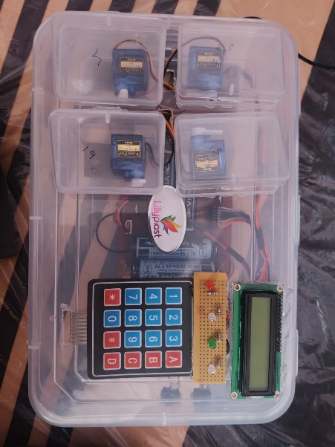
Fig. 1. The Pill Mate prototype’s hardware integration layout

- Software and Application Interface
The ESP32 firmware executes a sequence of four tasks on a per-dose cycle basis: triggering alerts at the appropriate time, activating the servo motor, monitoring the IR sensor for a return response, and sending the calculated action to the cloud. The physical keypad allows the patient to enter or modify their dosing schedule directly on the Pill Mate device. Additionally, the LCD gives the patient immediate confirmation that the schedule entry was accepted by the users.
At the same time, the Companion Mobile Application allows the caregiver to monitor the patient even if they are not physically present with the PillMate. The Companion Mobile Application allows the caregiver to view a live dashboard that lists the patient’s dosing history, as well as upcoming doses, and any incidents of missed doses. Additionally, caregivers will receive push notifications when a missed dose is registered and need to intervene; thus, they will not have to constantly monitor the Companion Mobile Application. Under offline
conditions, the ESP32 will still perform as normal and will queue up adherence records in memory until a connection is restored to the cloud. The companion mobile application interface, as shown in Fig. 2.
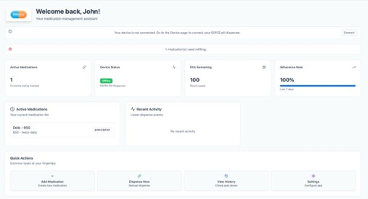
Fig. 2. The interface of the companion mobile application to monitor caregivers.

- Workflow

Fig. 3 shows a block diagram that depicts the entire system workflow. Each dose cycle starts at the Reminder Module, which uses the RTC to provide audio/visual alerts at the des- ignated time. This is followed by operation of the dispensing module, where the servo is commanded to open the appropriate compartment. The Verification Module will monitor the IR sensor and register the outcome of the dose dispensed. Finally, the IoT Monitoring Module will record the event to the cloud and notify the caregiver via the app if a dose was missed. No module is allowed to function out of order due to this linear pipeline, thus, the completion of each dose from all modules creates a complete, auditable record each time.

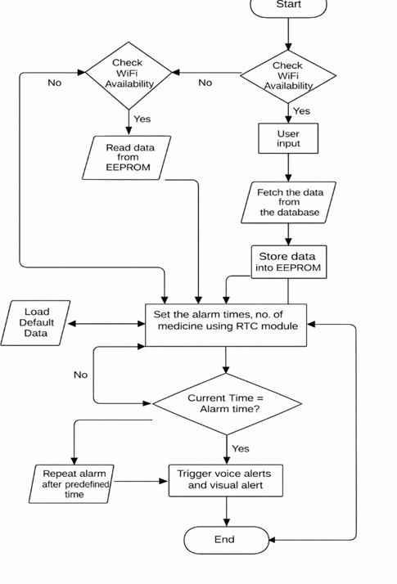

Fig. 3. Block diagram of the Pill Mate system workflow.

- Results and Discussion
A. Testing Procedure
A working prototype of the Pill Mate was created with the following components: the ESP32, RTC module, servo motor, IR sensor, buzzer, LED array, I2C LCD, and the companion mobile application. A variety of medication regimens were entered, with varied timing, for the multiple media test cases over multiple sessions in a controlled indoor environment on a reliable Wi-Fi connection. Each of the tests was repeated several times to collect consistency data and to identify edge cases.

B. Performance Metrics
Table I contains a summary of the key performance metrics collected during prototype evaluation.

TABLE I
Pill Mate System Performance Metrics

Parameter | Observed Result
Alarm Accuracy | 99%
Servo Dispensing Accuracy | 98%
IR Detection Accuracy | 95%
Caregiver Notification Delay | <5 seconds
Power Consumption | Low (battery-operable)

Table II contains a comparison of Pill Mate against a representative series of previous systems was performed across five key capability dimensions.

TABLE II
Comparative Analysis with Prior Systems

System | Auto  Disp. | Intake  Verif. | Remote  Mon. | Offline  Op. | Low  Cost
Minaam & Abd- ELfattah [1] | No | No | Yes | No | Yes
Chawariya et al. [3] | No | No | No | Yes | Yes
Jayseelan & Shanmugam [5] | No | No | Yes | No | Yes
Kim & Park [7] | Yes | No | Yes | No | No
Rao [8] | Yes | No | No | Yes | Yes
Pill Mate (Pro- posed) | Yes | Yes | Yes | Yes | Yes

C. Discussion
The 99% accuracy of alarms indicates that RTC-based scheduling provides a dependable foundation for dose timing and that the deviations observed from a prescribed dose occur within the acceptable range of clinical medication ad- ministration schedules. The 98% dispensing accuracy of the servo motor indicates the mechanical performance has been consistent throughout the multiple test cycles with only limited samples being associated with the mechanical failure due to wear from high cycle counts, rather than errors in the control logic.

While the IR detection accuracy of 95% showed the great- est variability during testing, the variance can be attributed to minor sensitivity fluctuations of the passive IR sensor due to substantially altered ambient light. This variance is characteristic of passive IR sensors operating in uncontrolled environments, and did not interfere with the IR sensor’s ability to accurately identify dosage outcomes in a typical indoor environment. Future hardware corrections to account for this variance include use of either shielded sensor enclosures or use of active IR emitter pairs.
Notifications to caregivers were provided in less than five seconds following the missed-dose event; therefore, the five- second latency is negligible in the context of medication management and provides sufficient time for a caregiver to respond to provide timely intervention. The small amount of power consumed by the Pill Mate supports the use of a rechargeable battery backup, which is highly relevant when supporting elderly consumers who may forget to charge the unit.
The comparative analysis presented in Table II reveals the differences between Pill Mate and other existing solutions. Most of the reviewed solutions are able to deliver one or two of the five functions that Pill Mate can provide. None of the other systems being compared were able to provide all five of these functions at the same time. As such, Pill Mate is the only solution in this study that provides all five of these functions
in an automated, integrated manner to close the gaps identified
by the authors in their review.
- Summary and Conclusion
In conclusion, Pill Mate is an IoT-based system designed to track and confirm medication adherence (i.e,. confirming that the prescribed dose was actually taken). This new project incorporates automated dispensing, intake detection with in- frared (IR), schedule time from a real-time clock (RTC), and caregiver alerting via the Internet, all into one platform based on an ESP32 chip. As a result, Pill Mate creates an accurate, complete, closed-loop medication management process that does not require patients to do anything except take the medication that has been dispensed.
The prototype evaluation showed excellent performance on all five core operations, such as an alarm accuracy rate of 99%, dispensing accuracy rate of 98%, and notification delay of less than five seconds. After conducting side-by-side comparisons with other device types to measure the performance levels of the various critical operations, no device reviewed could perform all five critical operations simultaneously.
The future development for Pill Mate will include multiple avenues for continued enhancement. Developing a machine learning algorithm to specifically identify unusual or abnormal behavior, such as opening of compartments at times other than the designated scheduled time/s, may help confirm the verification of adherence even further. The future could also involve development of multiple patients being supported by the Pill Mate platform (for use in clinics or assisted living facilities).

Additionally, connecting Pill Mate(s) to electronic health records (EHR) in hospitals will allow doctors to integrate and utilize real-world data on patients’ adherence to their prescribed medication into their treatment decisions. Other opportunities may include researching new detection modalities of consumption (for example, using weight sensors to confirm that an individual has consumed their medication), which could help confirm consumption more accurately than the use of IR sensors currently being employed. Finally, minia- turizing the hardware form factor of Pill Mate for possible installation in a wall-mounted or integrated bedside position will make it more usable and less intrusive to home users.
References
- D. S. Abdul Minaam and M. Abd-ELfattah, “Smart drugs: Improving healthcare using smart pill box for medicine reminder and monitoring system,” Future Computing and Informatics Journal, vol. 3, no. 2,
pp. 443–456, 2018.
- H. Huang, L. Zhang, Y. Yang, L. Huang, X. Lu, J. Li, H. Yu, S. Cheng, and J. Xiao, “Construction and application of medication reminder sys- tem: Intelligent generation of universal medication schedule,” BioData Mining, vol. 17, no. 23, pp. 1–12, 2024.
- A. Chawariya, P. Chavan, and A. Agnihotri, “Fundamental research on medication reminder system,” International Research Journal of Engineering and Technology (IRJET), vol. 6, no. 7, pp. 3474–3477, 2019.
- S. Faisal, J. Ivo, and T. Patel, “A review of features and characteristics of smart medication adherence products,” Canadian Pharmacists Journal, vol. 154, no. 5, pp. 312–323, 2021.
- J. D. Jayseelan and S. D. B. Shanmugam, “Smart pill box using IoT and cloud,” Bioscience Biotechnology Research Communications, vol. 13, no. 4, pp. 146–152, 2020.
- J. D. Jayseelan and S. D. B. Shanmugam, “Smart pill box using IoT and cloud,” Bioscience Biotechnology Research Communications, vol. 13, no. 4, pp. 146–152, 2020.
- A. Abhijith M., A. Aadith S., A. Kumari Gond, K. Krishna G.,
D. Dhanasri G., B. Bhavani, and K. Selvavinayaki, “IoT-based smart medicine dispenser: A technological solution for medication adherence,”
J. Neonatal Surg., vol. 14, no. 14S, pp. 206–211, Apr. 2025.
- P. Dayananda, Development of Smart Pill Expert System Based on IoT, 2024.
- C. H. Patil, N. Lightwala, M. Sherdiwala, and S. M. Mali, “An IoT based smart medicine dispenser model for healthcare,” in Proc. IEEE World Conf. Applied Intelligence and Computing, 2022.
- “Smart medication management: Enhancing medication adherence with an IoT-based pill dispenser and smart cup,” in Proc. IEEE AimHC Conference, 2024.

